AI ASSISTED CODING
ASSIGNMENT-17
Name: D.Shruthi
HT No: 2303A52407
Batch: 31

Task 1: Perform EDA on Penguin dataset(from seaborn)
• Load and display entire dataset
• Display country wise count
• Visualize bar chart (country wise)
• Visualize bar chart with values count at top
• Visualize pairplot and other plots
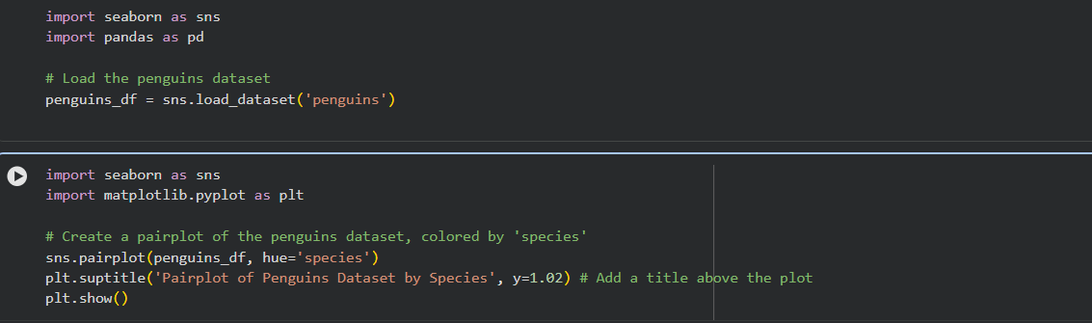

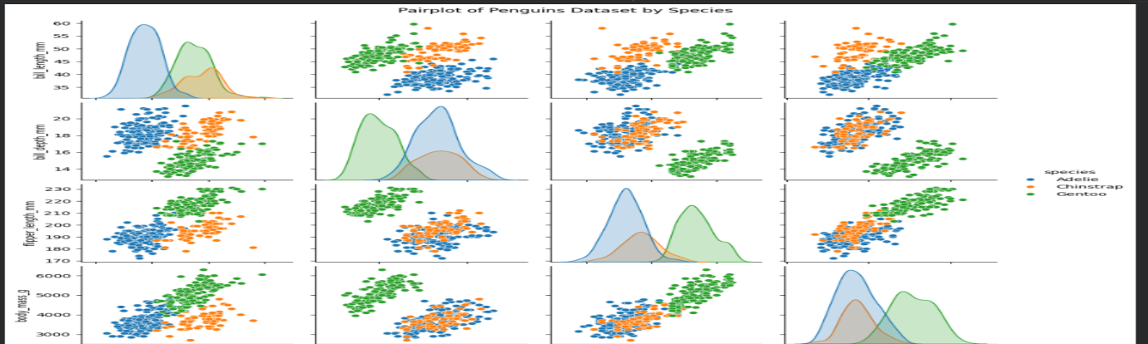
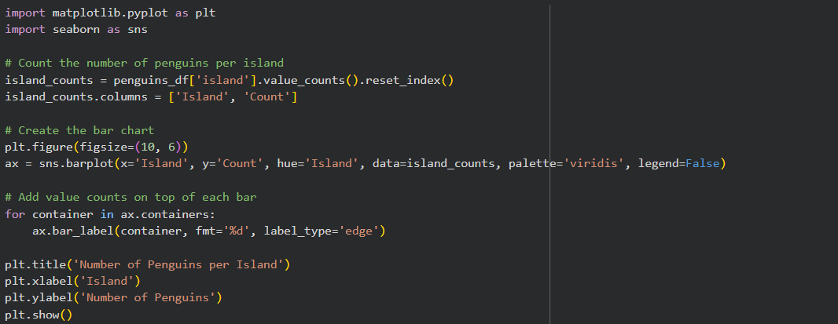
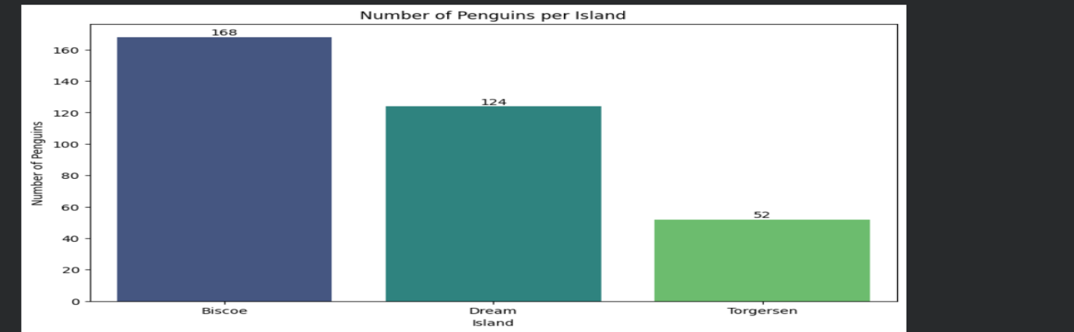
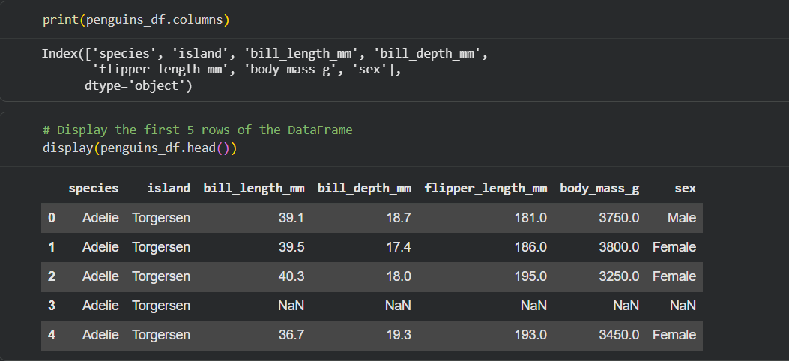

Task 3: Perform following task on given dataset (Train
the model)
• Analyze the Planets dataset to understand its
structure, features, and missing values.
• Perform data cleaning and preprocessing to
handle missing or incorrect data.
• Train the dataset using different machine learning
models to make predictions.
• Compare and explain the performance of all
trained models with proper reasoning.
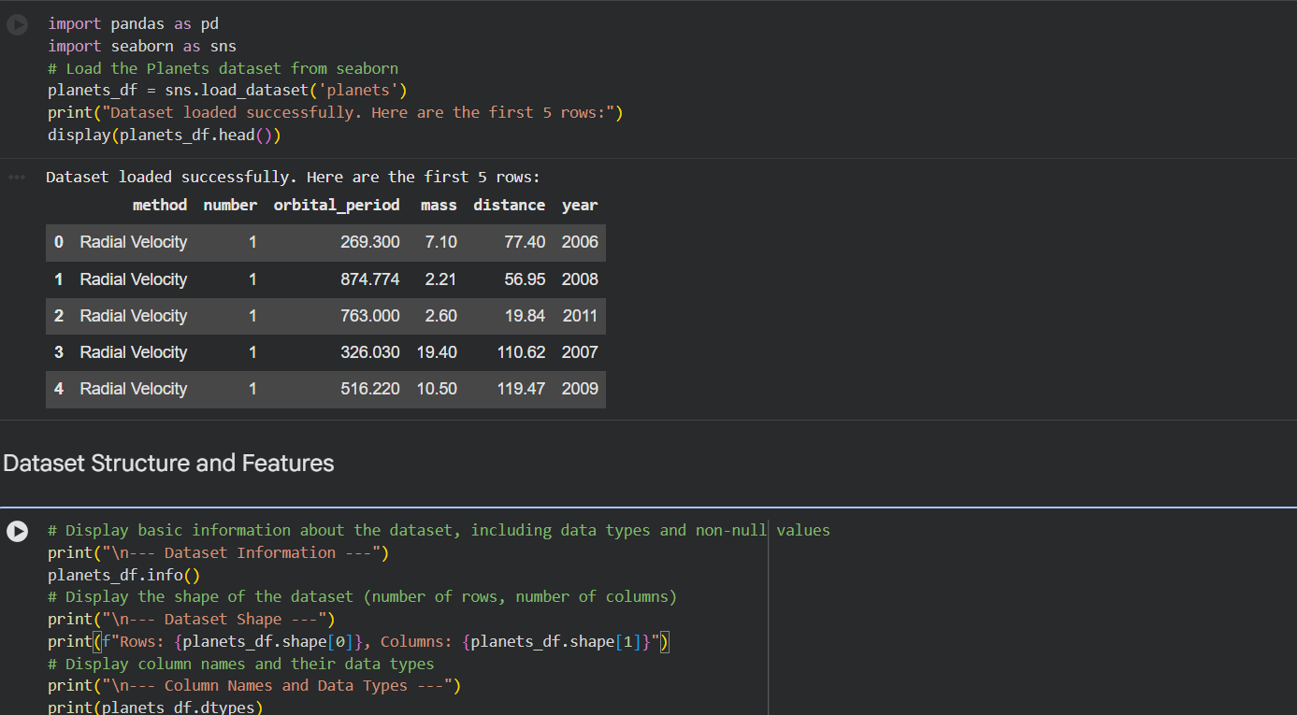
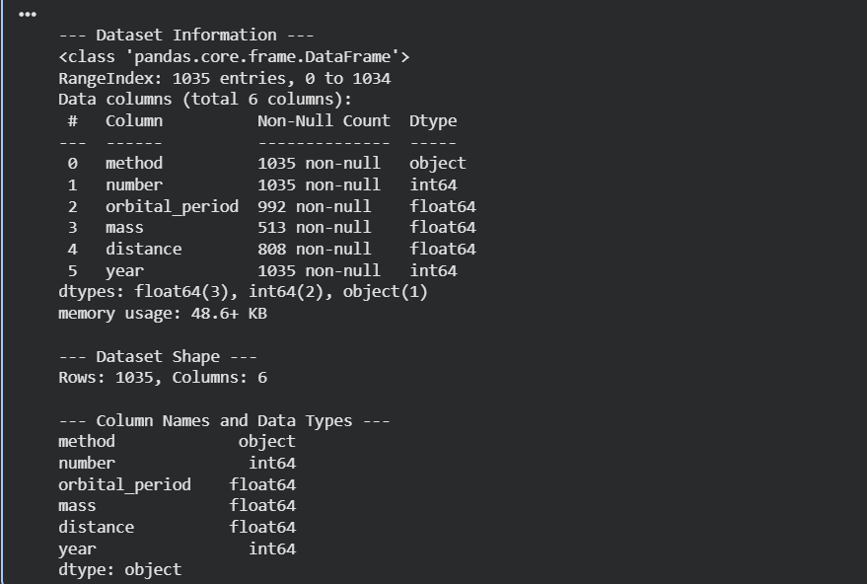
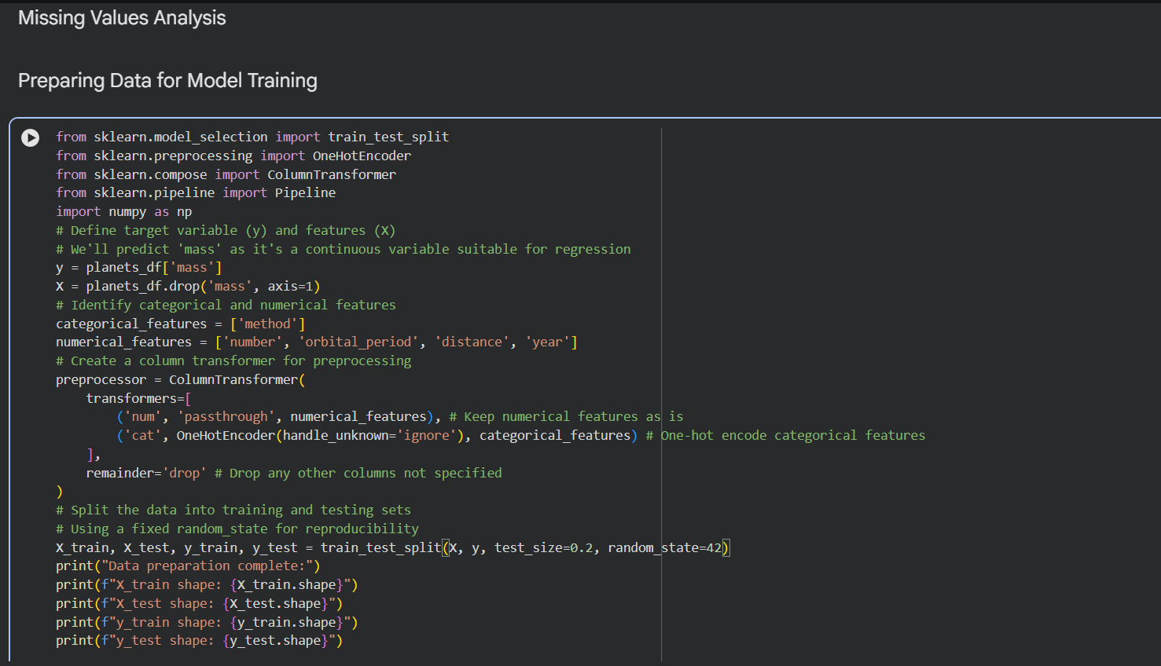
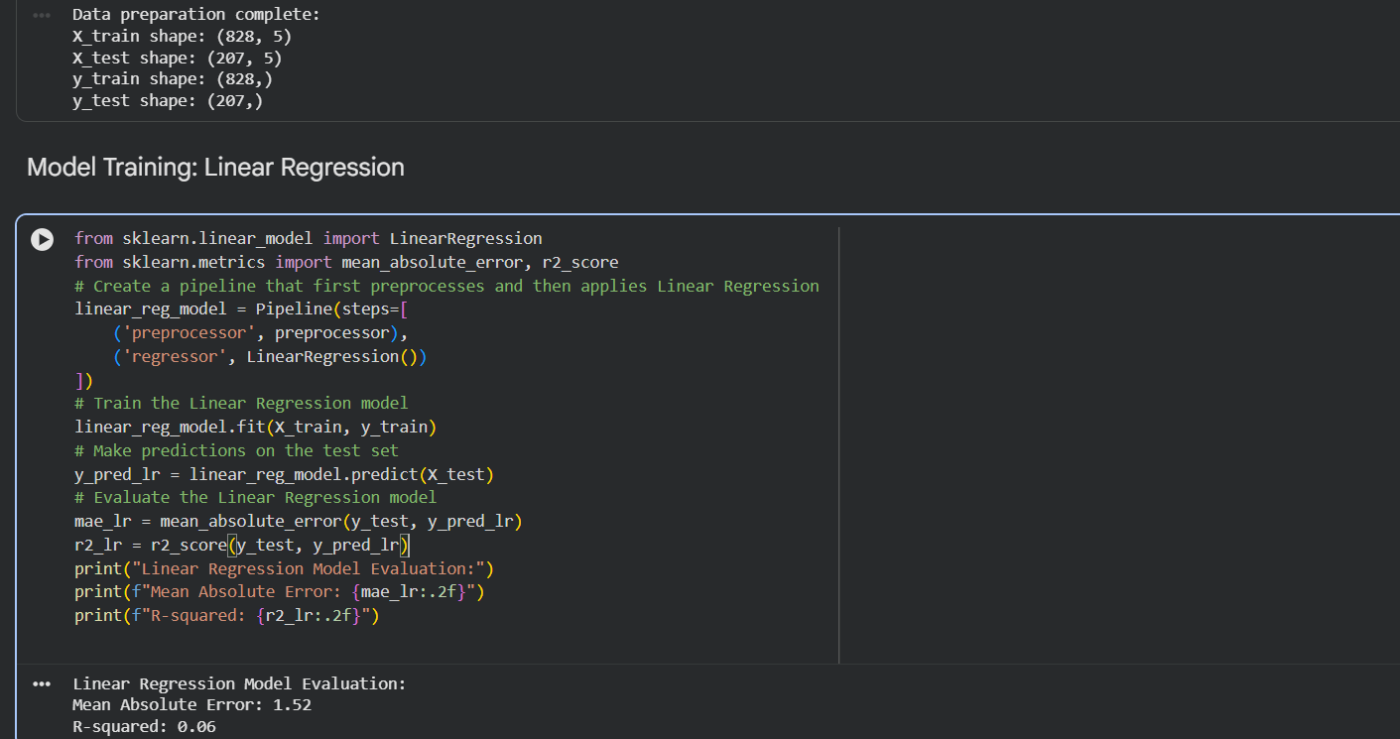
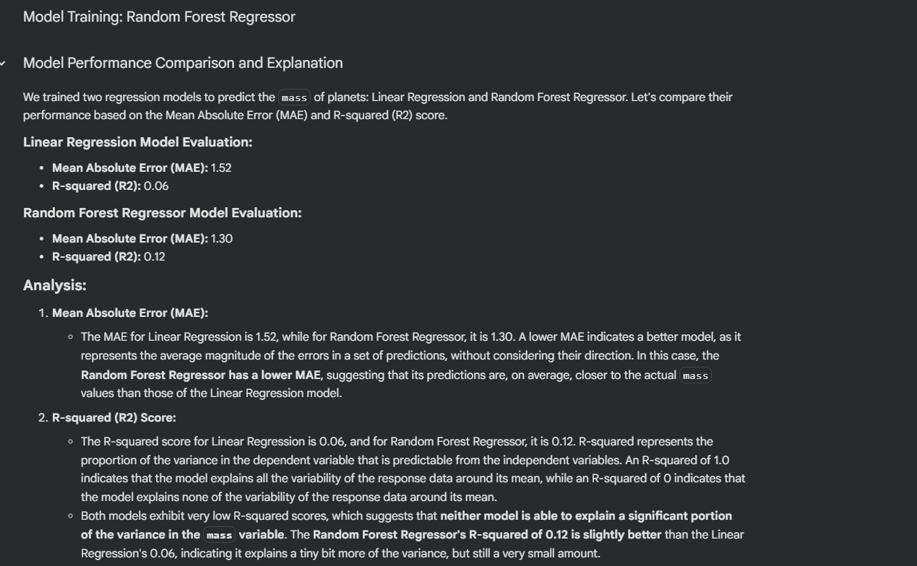
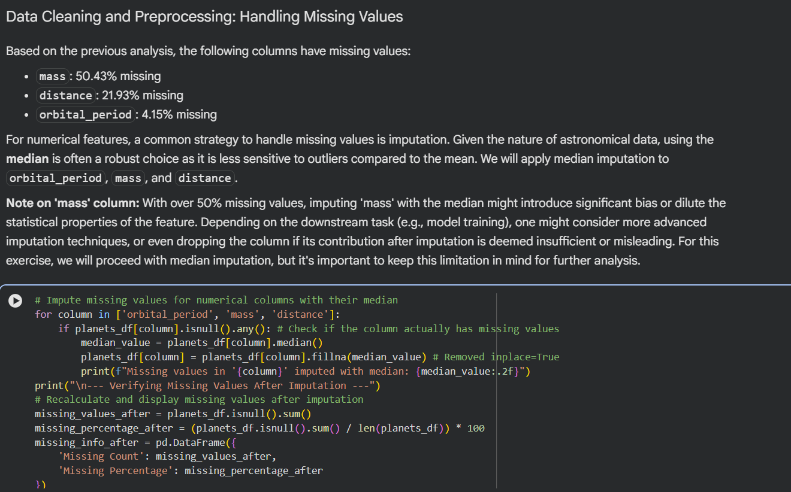
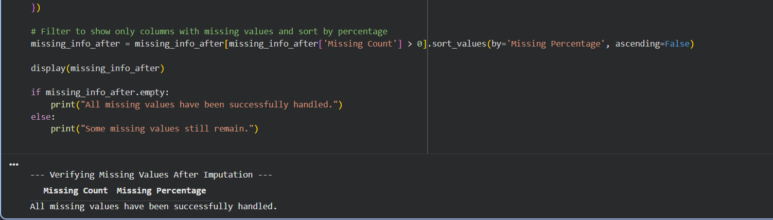
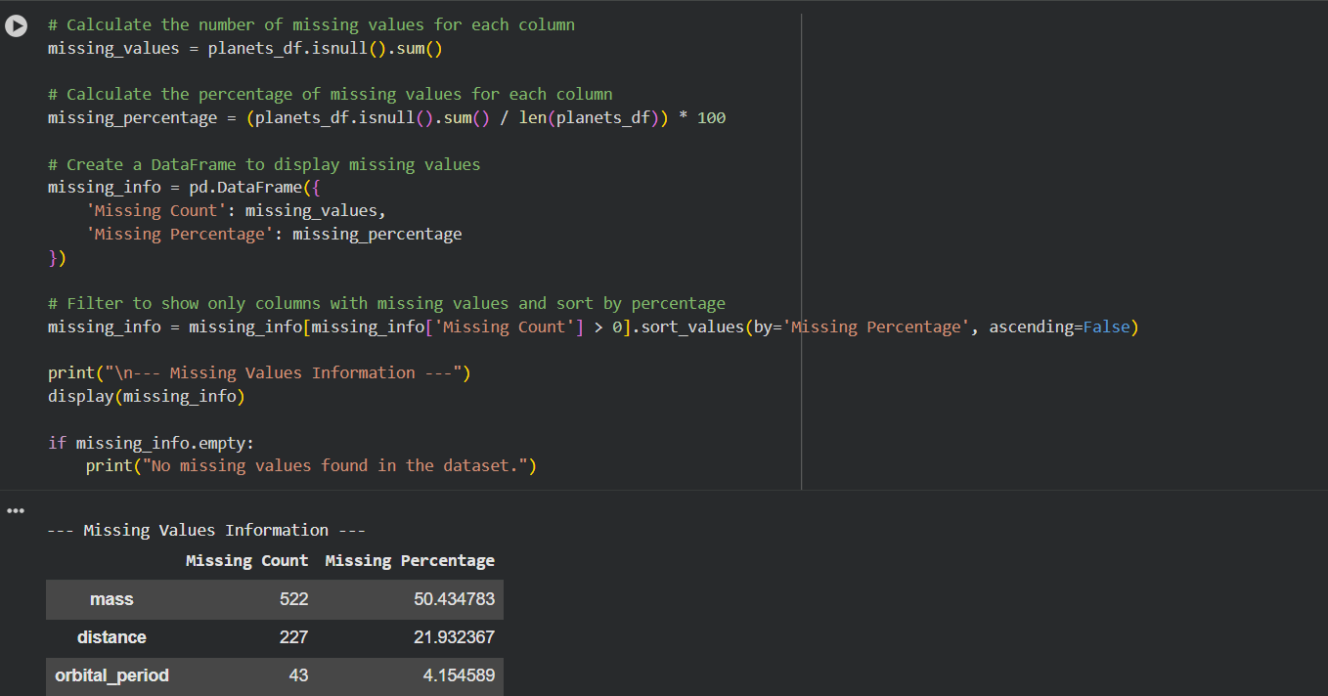

Task 4: Perform following task on given dataset (Train
the model)
• Load the MNIST dataset from PyTorch.
• Display basic information and visualize sample
input images with their class labels.
• Perform data preprocessing
• Design a EfficientNet model for image
classification.
• Train the CNN model (10 epochs)
• Evaluate model performance using accuracy and
loss metrics.
• Visualize the training history (accuracy and loss
curves).
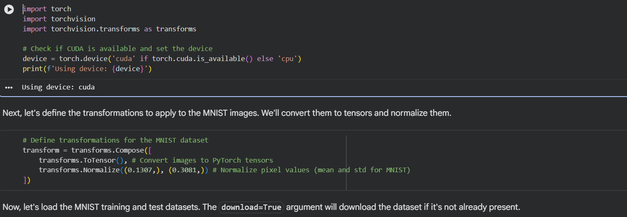
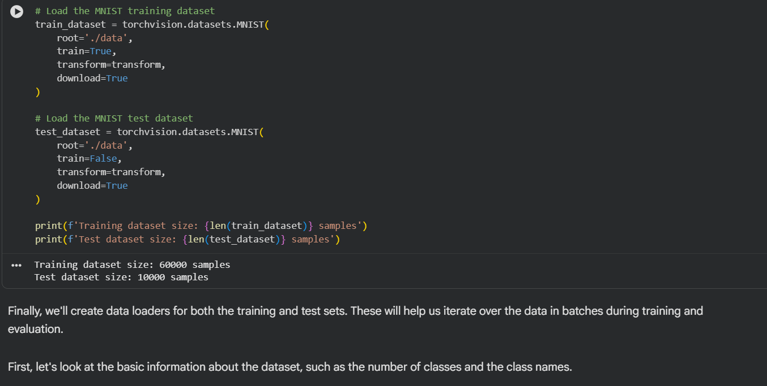
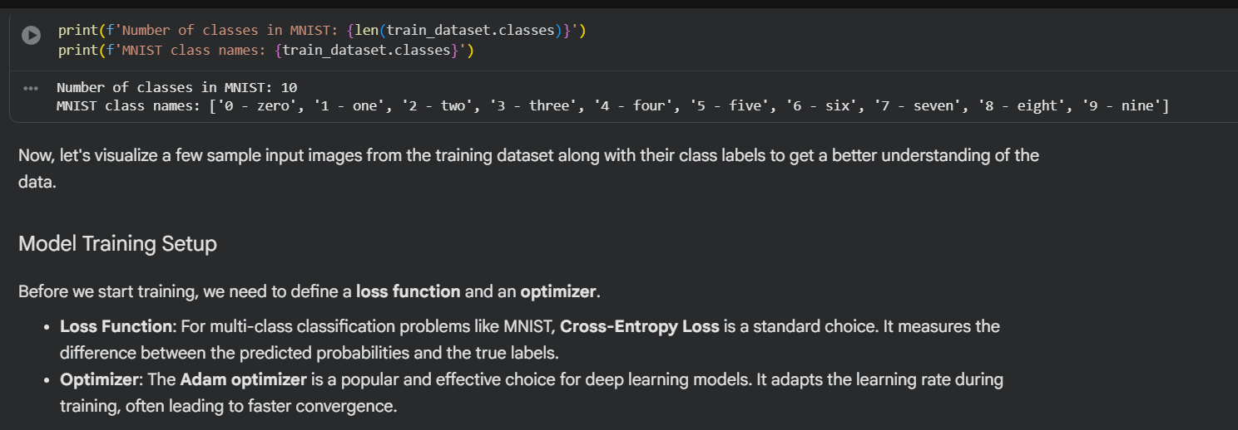
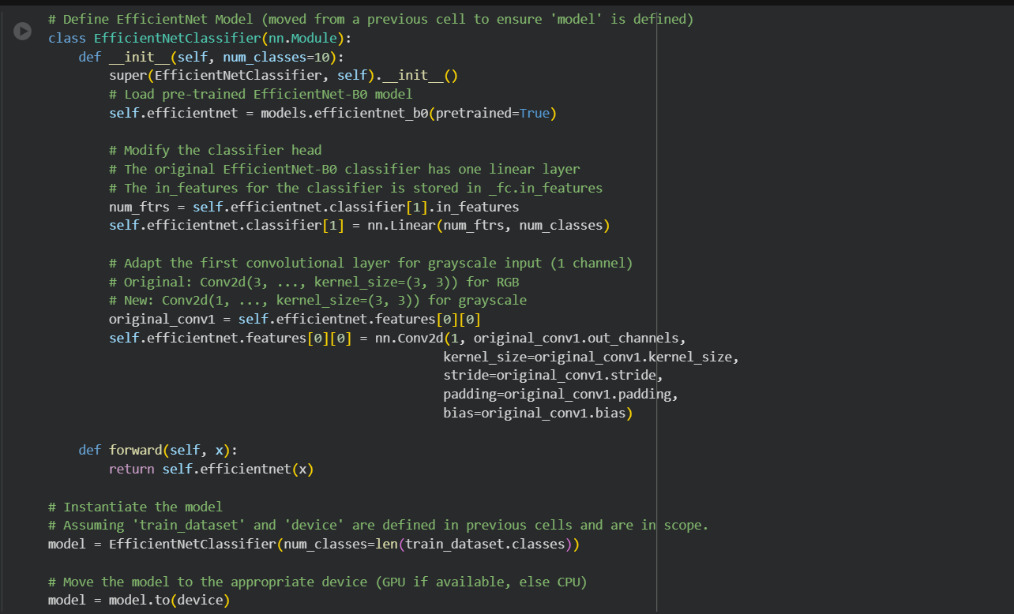
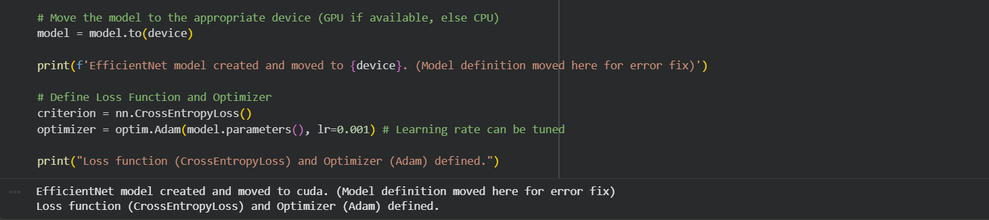
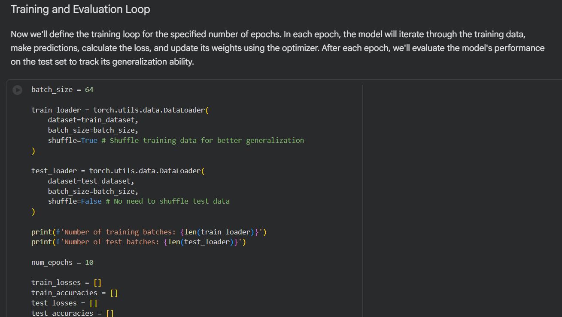
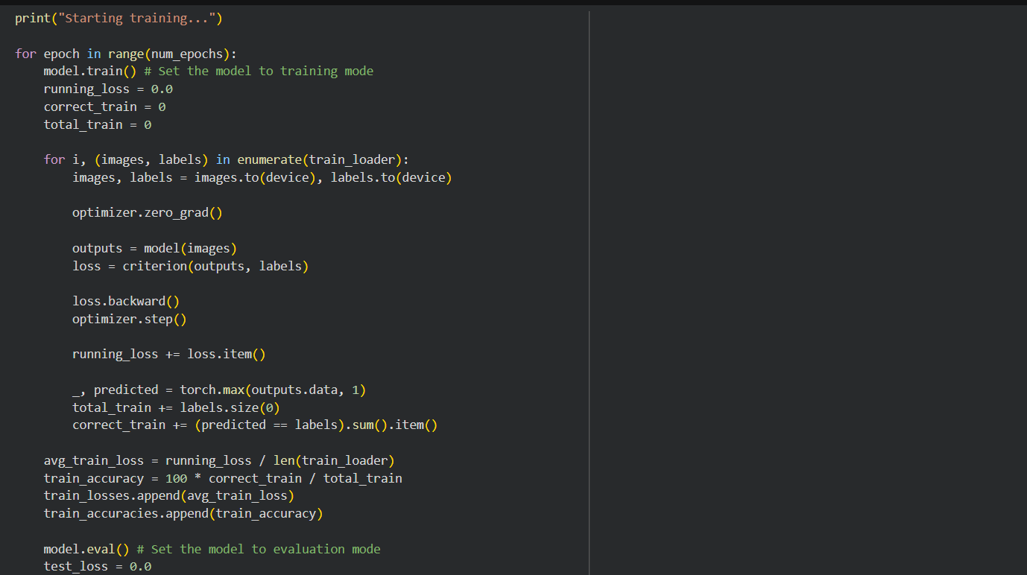
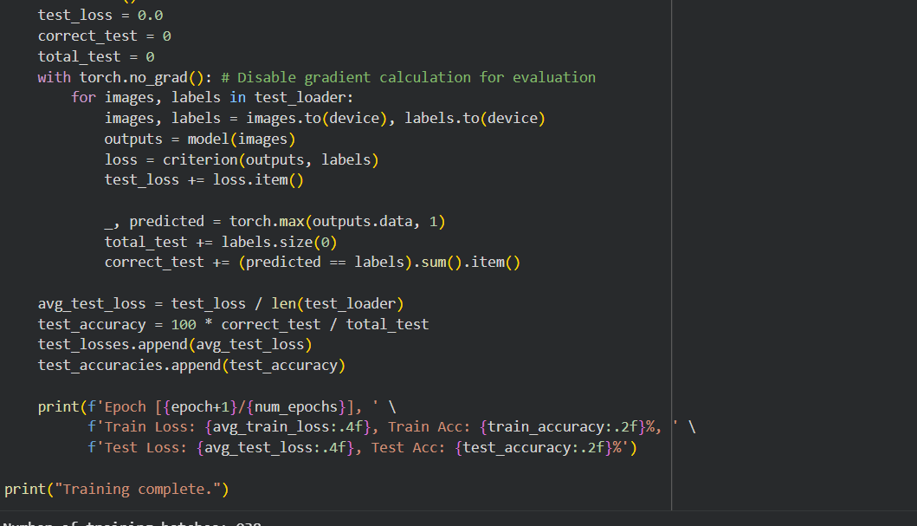
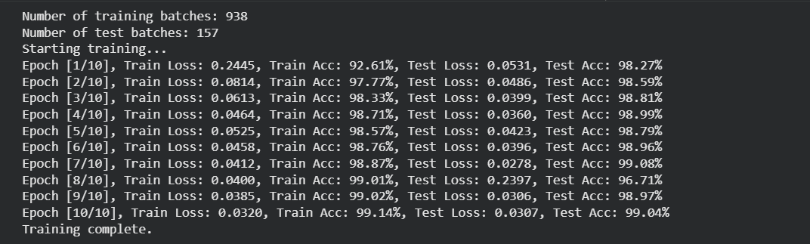
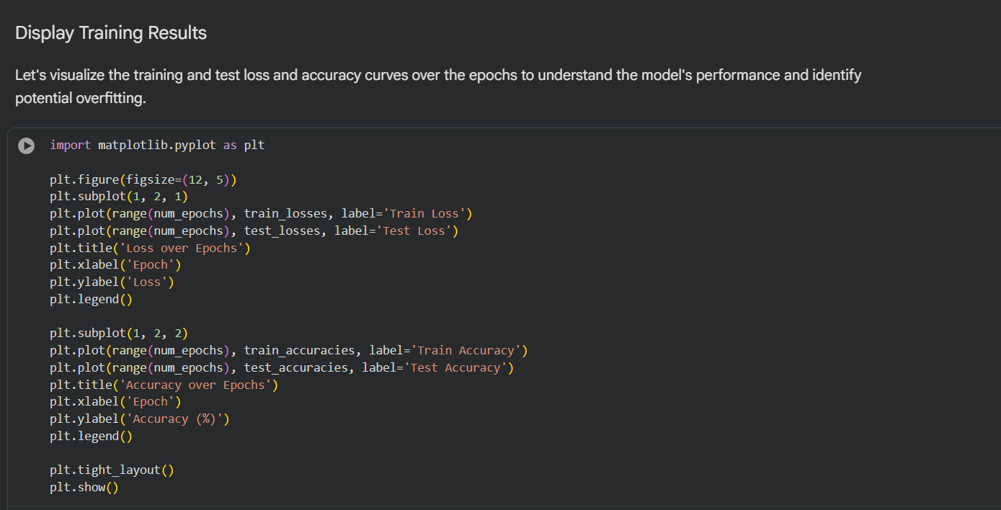
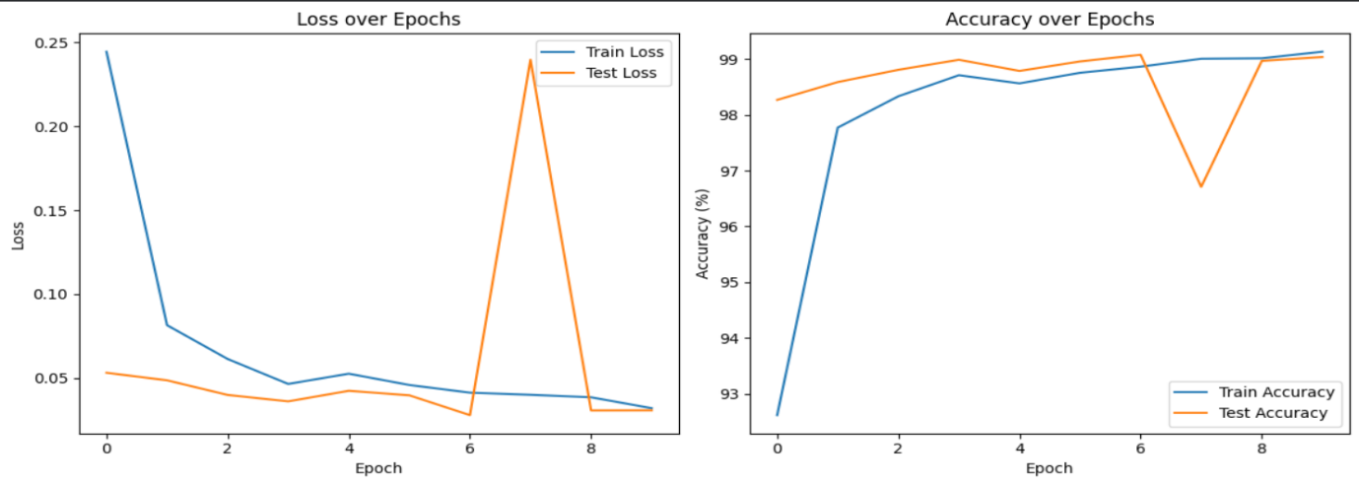
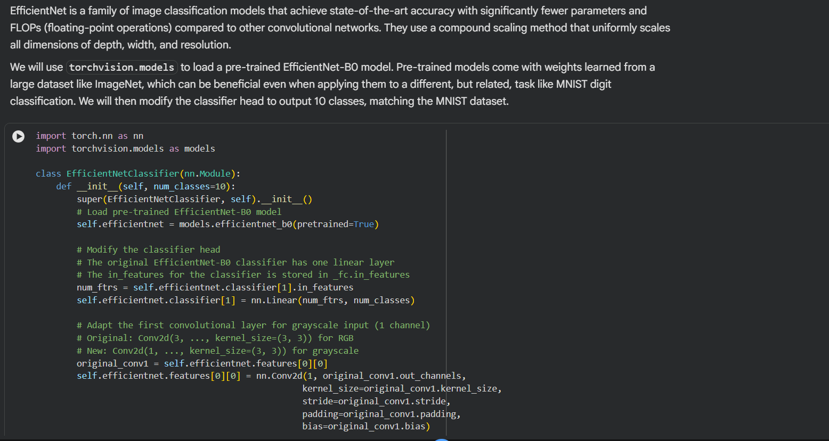
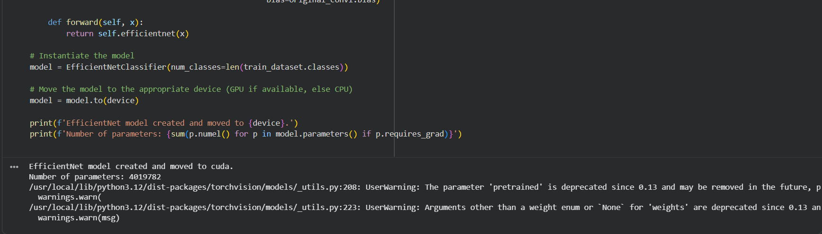
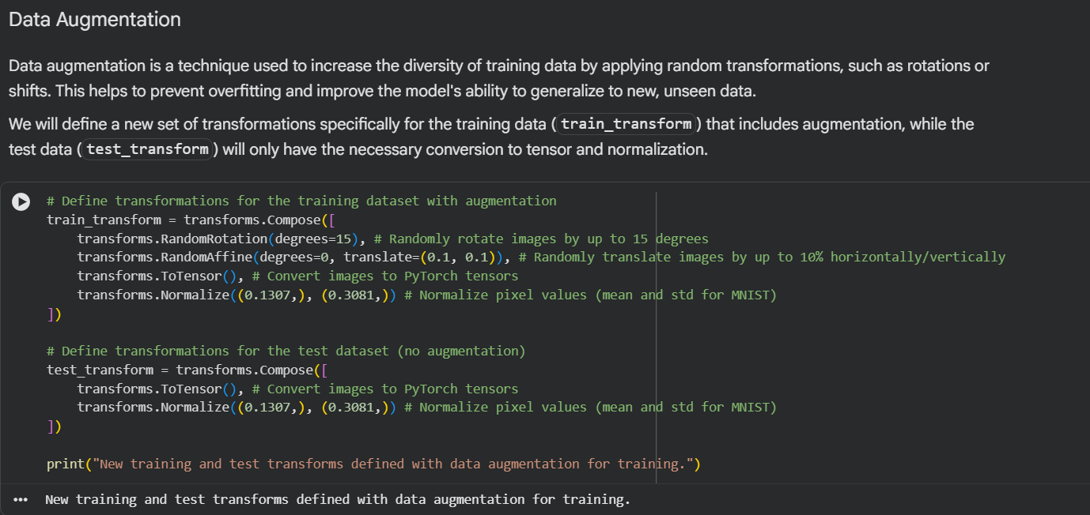
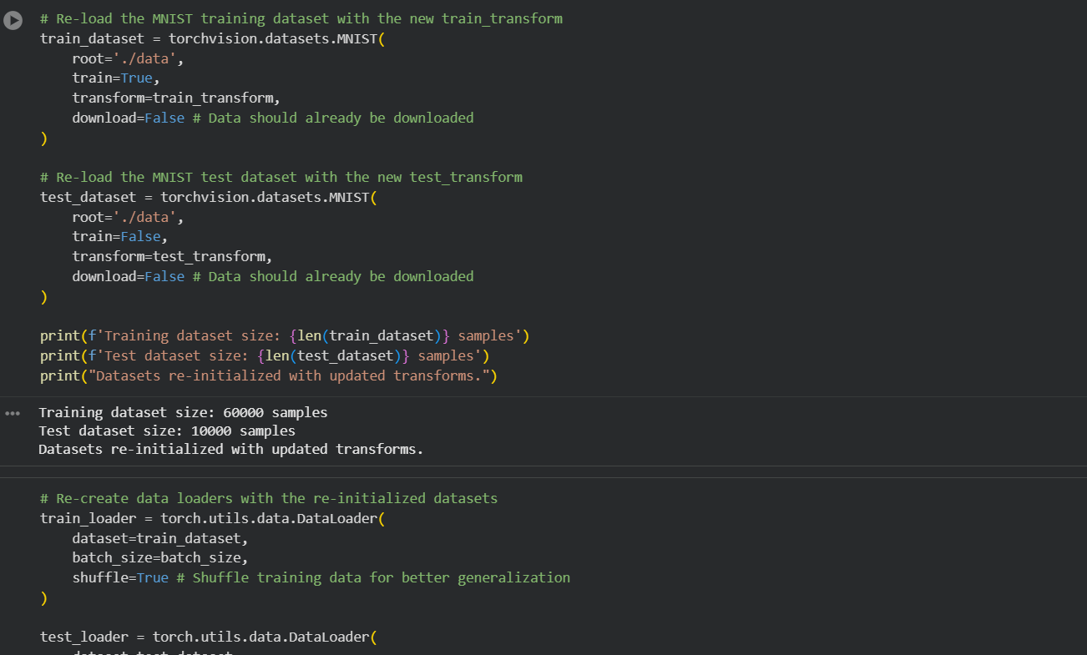
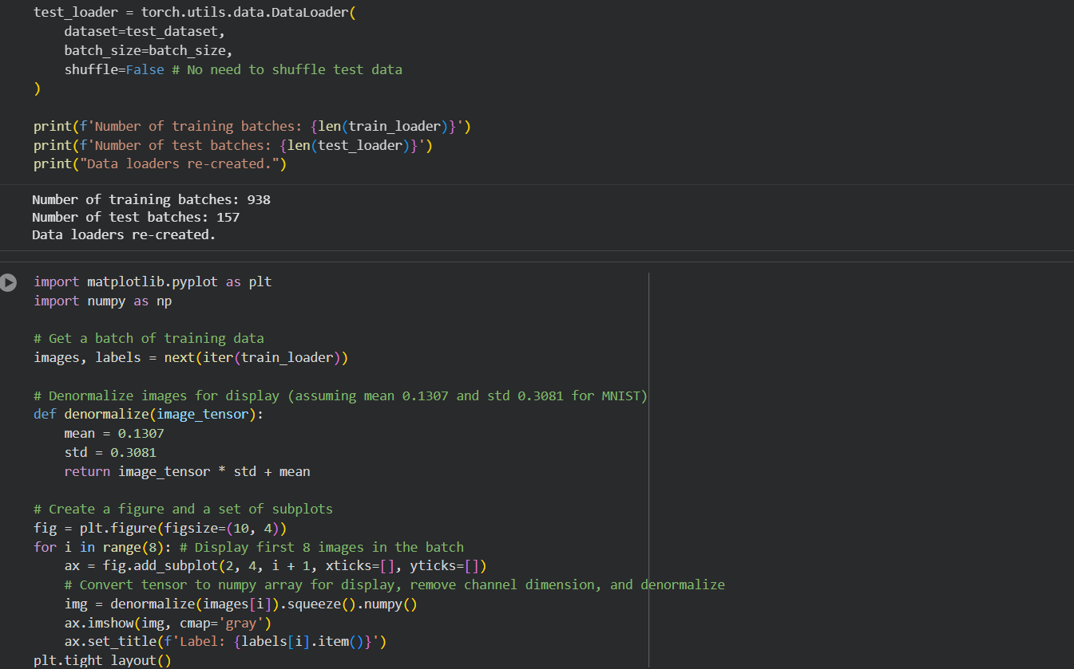
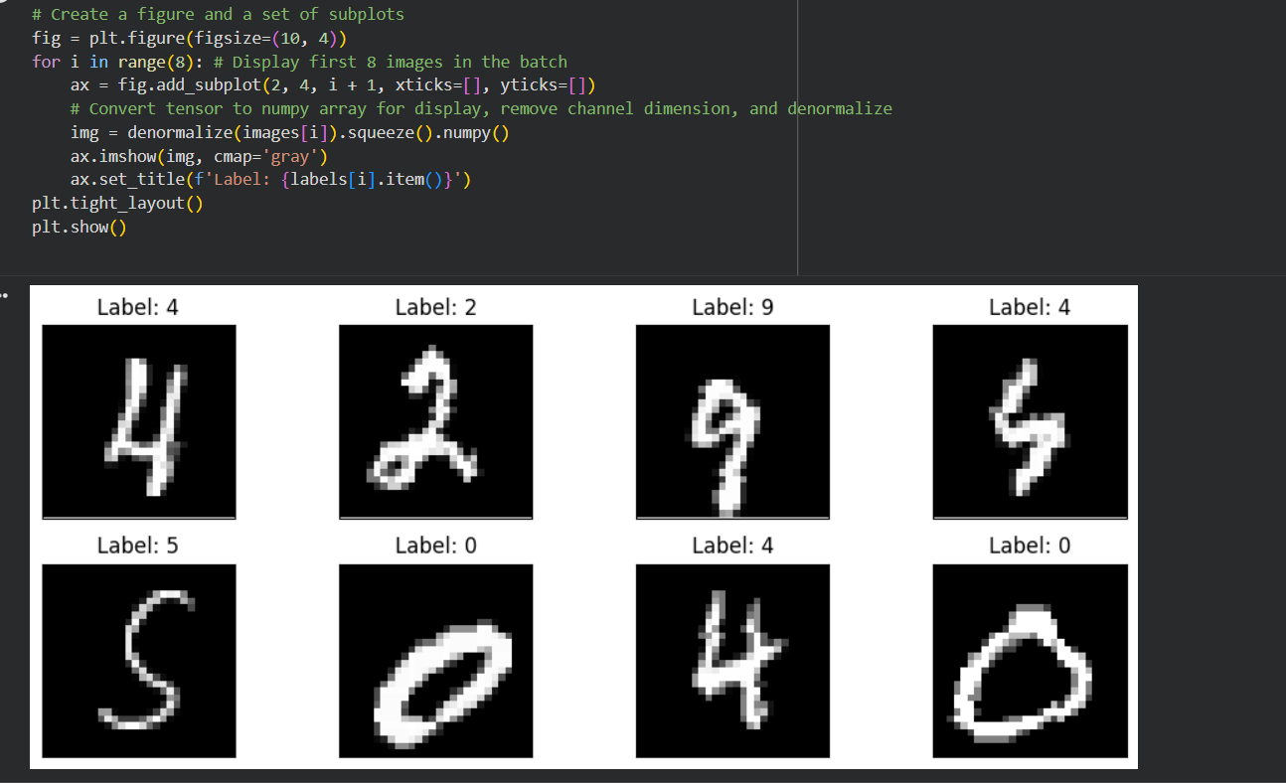
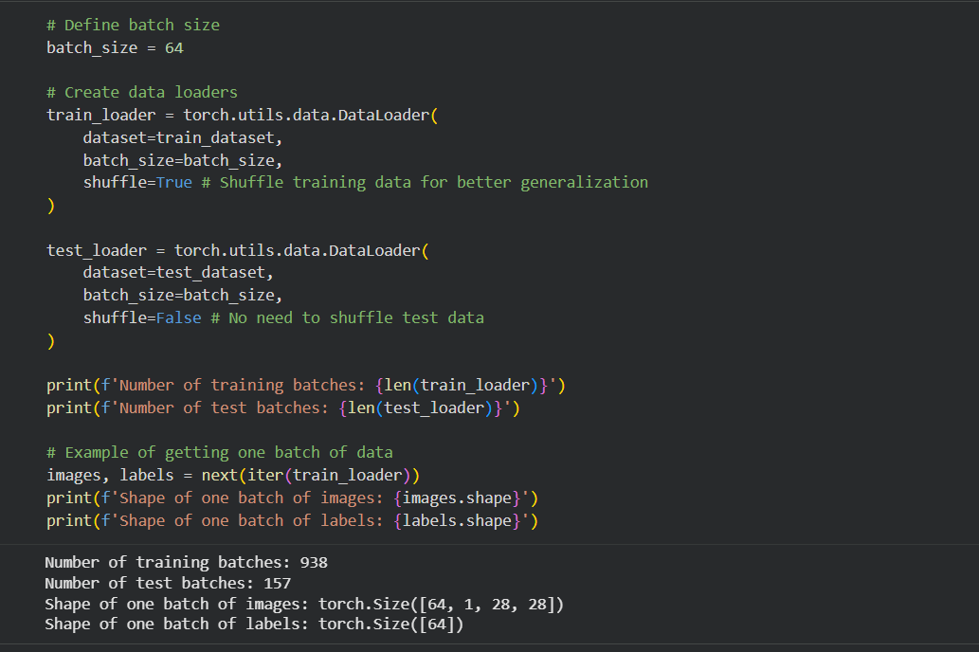

Task 7 – Healthcare Data Preparation
Task:
Clean and preprocess a healthcare dataset using AI scripts.
Instructions:
• Handle missing values in blood_pressure, cholesterol.
• Encode categorical features
• Scale numerical features (min-max or standard
scaling).
• Split dataset into training and testing sets.
Dataset link :
https://www.kaggle.com/datasets/abdallaahmed77/healthcare-
risk-factors-dataset
Expected Output:
• A preprocessed dataset ready for machine learning
models.
